A000-Indo-Sumba-Nusa Tenggara Province-Ancestor with Crocodile Protector-Limestone-Late 19th c

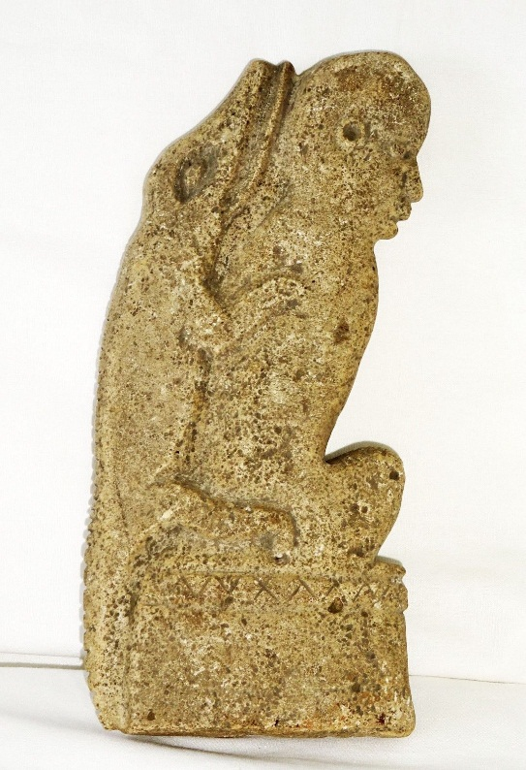 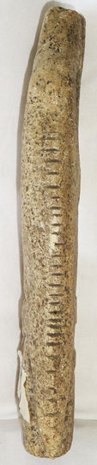-

# **Formal Label:** Sumbanese Ancestral Limestone Figure with Crocodile Protector

# Case No.: Oceania

**Accession Number:**

**Display Description:**

Sumba in eastern Indonesia is one of the Lesser Sunda Islands, in East Nusa Tenggara. Sumba Island migrated over the last 120 million years from the landmass of Australia.

Sumbanese are a vanishing megalithic culture in which ancestor worship plays a major rôle. Hilltop villages’ thatched roof-spires of clan houses encircle megalithic ancestor tombs and their dynamic and mutable animal protectors like this crocodile, that pervade all things seen and unseen, such as water, trees and rocks.

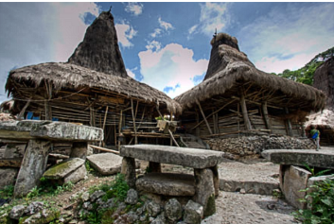

**The village where this sculpture came from.**

In the example above, the ancestor before his death scribed 24 notches on this limestone sculpture to indicate how many times the crocodile spirit aided him in life on earth. This also indicated that ancestors were active in determining the sculpturing of their votive offerings and perhaps their megaliths as well. Sumbanese place effigies in the shape of ancestors and their animal protectors, such as the crocodile, like the limestone figure above, in their gardens or inside their traditional thatch-roofed houses.

About 30 percent of the indigenous population practice Marapu animism, which is often combined with Christian worship. Since life on earth is temporary, one must prepare for an eternal life with the world of spirits in Prai Marapu, a heavenly spirit world, by living a balanced life on earth aided by Great Mother (Ina Kalada) and Great Father (Ama Kalada) who gave birth to the first Sumbanese and whose visible forms are the moon and the sun. In *Prai Marapu* spirits lead a human-like existence in couples and consist of two elements, *Ndewa* and *Hamanangu*, symbolized by the Great Mother (*Ina Kalada*) and the Great Father (*Ama Kalada*). They assume the forms of the moon and the sun, as husband and wife, who gave birth to the ancestors of the Sumbanese. Their power is great: They have a mysterious psychological influence over human life, in which they can project a psychosomatic image of life on the minds of people that encourages them to attain happiness by striving to achieve unity in harmony.

The existential impact of *Prai Merapu*, unity in harmony, on the East Sumbanese today is reflected in their building megalithic stone burial monuments in the center of clusters of their high peak thatched clan houses that earns them the distinction of being one of the last megalithic cultures on Earth.

**LC Classification:**

**Date or Time Horizon: late 19th to** early 20th century

**Geographical Area:** Sumba Island, East Nusa Tenggara Province, Indonesia

**Cultural Affiliation:** Sumbanese Culture

**Medium:** Limestone

**Dimensions:** H 8.5 in, W 4 in

**Weight:**

**Provenance:** Andrès Harnisch, Honolulu, Hawaii, 2004.

**Condition:** Museum Quality

**Discussion:**

**References:**